**Year 12 ATAR PHYSICS**

**Practical Test WAVES AND QUANTA**

**Part A: DETERMINING PLANCK’S CONSTANT**

**Marks: /20**

**ANSWERS**

**Equipment operation:**

1. Set the power supply voltage between 9 and 12 Volts DC.

2. Set the digital meter connected to the “A” terminals to a DC range of about 200uA.

3. Set the digital meter connected to the “V” terminals to a DC range of about 20 volts.

4. Set the rotary LED selector switch to select the 465 nanometre wavelength LED.

5. Starting at the “min” position, increase the voltage applied to the LED until the current

through the LED reads 2uA on the digital meter set to micro amps.

6. At 2uA through the LED, note and record the voltage applied to the LED by reading the digital meter set to volts.

7. Repeat steps from 4 to 6 after selecting the next LED.

**(2 marks, -1 for each request for help, unless equipment problem related)**

**EXAMPLE DATA**

|  |  |  |
| --- | --- | --- |
| Vth | (Read from the dial) | Frequency (f) |
| 1. Data column |  | 1. Calcs column |
| 2.317 V | 465 nm | 6.45 X 1014 Hz |
| 1.837 | 520 | 5.77 |
| 1.584 | 594 | 5.05 |
| 1.289 | 620 | 4.84 |
| 1.344 | 660 | 4.55 |
| 0.859 | 880 | 3.41 |
| 0.792 | 940 | 3.19 |

(2 marks)

8. Plot V vs f results on the following graph (grid over the page). (4 marks)

**(1) scales (1) labels (2) accurate plotting**

9. Draw a line of best fit. (1 mark)

**GRAPH:**

FREQUENCY X 1014 HZ

V

O

L

T

S

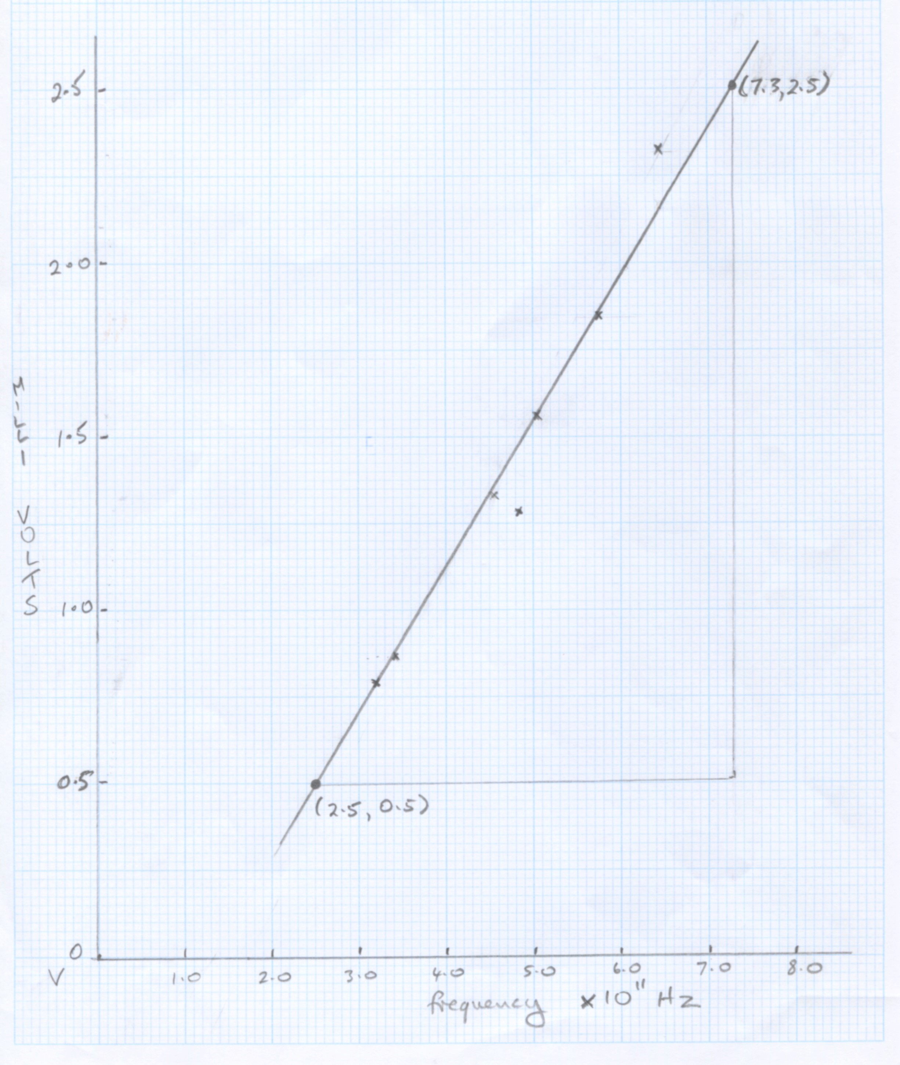

10. Calculate the gradient showing clearly on the graph where you have taken the points.

(3 marks)

**Gradient = (2.5 - 0.5) (1) method shown on graph**

**(7.3 – 2.8) x 1014**

**= 4.44 x 10-15 Vs (1) ANS (1) units [VHz-1 ok!]**

11. Use the gradient to calculate h. (4 marks)

**eVth = hf , so Vth = hf / e**

**gradient = h/e (1)**

**h = gradient x e = 4.44 x 10-15 x 1.6 x 10-19**

**= 7.1 x 10-34 (1)**

**2 sig figs (1)**

**Range: 6.5-7.5 x10-19 (1)**

12. List where sources of random and systematic errors may occur when conducting the above experiment: (3 marks)

**Any reasonable answer, must be in correct category**

**RANDOM: display on digital meters**

**Drawing line of best fit**

**SYSTEMATIC:**

**Resistance in wires (poor connections): (Random??)**

**Calibration of meters**

**Inaccurate value for wavelength of LEDS:**

13. Identify one method which would help to minimise the errors. (1 mark)

**Use higher quality meters**

**Use high quality connectors, expand banana leads etc**

**Check wavelengths with spectrometer.**

**Repeat lab or combine class results.**